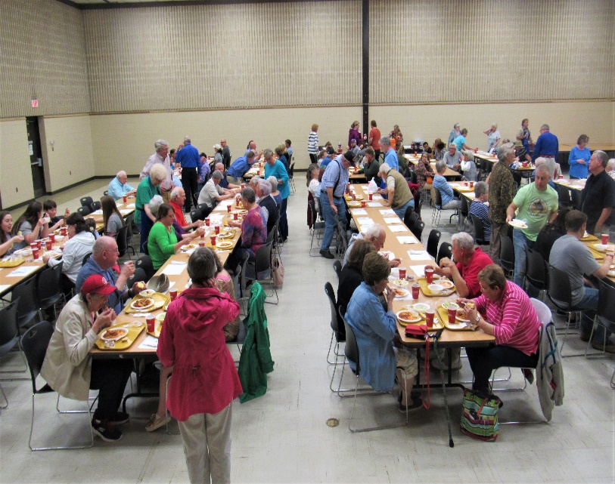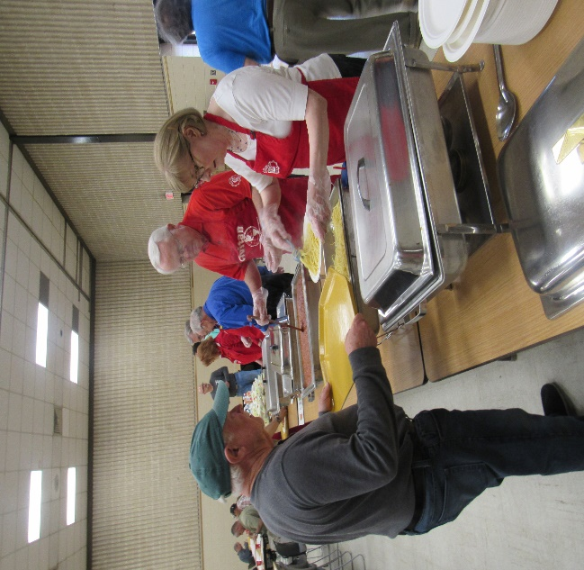
The Civitan Club of Salisbury’s annual Spaghetti Feast will be held on Friday, April 17, 2020, at the Salisbury Civic Center. This event features mouthwatering al dente spaghetti, secret sauce, toasted garlic bread, nutritious salad with dressing of your choice, dessert, and a drink for only $9.00 in advance or $10 at the door.
Advance tickets are available from any Civitan Club Member. Lunch begins at 11:00 a.m. and continues until 2:00 p.m. Doors open for dinner from 5:00 – 7:00 p.m. For orders of 10 or more meals, we will DELIVER to your designated location. Children under 6 years old eat FREE. Take-outs are available for lunch.
The Spaghetti Feast benefits the Special Olympics, The ARC of Rowan, the Civitan Research Center, and Victory Junction Camp. In addition, the club awards over $14,000 in scholarships to high school and college students, hosts the Rowan County teachers of the year, and honors local clergy, Rowan County heroes, and Good Samaritans.
Honor your employees, family, or friends with tickets to such a worthy cause. For further information, contact Spaghetti Feast Chairman Nathan Dickert, at 704-223-7000.
The Salisbury Civitan club is one of the oldest continually operating clubs in the nation. Members have been working behind the scenes in our community for over 95 years. Formed in 1922, the club was just the 80th group of its kind in the entire nation. Today, it is one of the largest and most active clubs in North Carolina.

